Mechanical properties of materials can be measured using tension/compression tests in order to quantify strength and ductility. In a tension test, strain is applied uniaxially along the sample and the force is continually increased on both ends until fracture occurs. The elongation and applied stress are measured during the experiment. By measuring force compared to the sample elongation, we obtained Young’s Modulus, Ultimate Tensile Strength, engineering stress and strain, true stress and strain, and Yield Strength. Young’s Modulus (E) is a relation of stress(σ) and strain(ε) by Hooke’s law by σ=εE and is a measure of a material’s resistance to elastic deformation, which increases with bond strength. This only occurs when stress and strain is proportional, otherwise plastic deformation occurs. Through plastic deformation, the maximum stress modeled in a stress versus strain curve that will result in fracture if it is maintained. There is a decrease in the cross-sectional area of the necking region resulting in a reduction in the load-bearing capacity of the specimen. When necking transpires stress is defined by $$σ_{T}=K{{(∈}_{T})}^{n}$$, where $$σ_{T}$$ is the true stress, K is the strength index of the material, and $$∈_{T}$$ is the true strain, and n is the strain hardening constant.

From the tensile test, we obtained true stress and strain of the material and from true stress and strain, we can derive engineering stress and strain. Engineering stress (δ) is the force applied (F) over the original cross-sectional area of the sample (A0), δ=F/A0. The Engineering strain ($$ϵ$$) is the change in length ( $$∆l)$$ compared to the original length of the material ($$l_{0})$$, $$ϵ=∆l/l_{0}.$$ True stress ( $$δ_{T})$$ is the force applied to the sample (F) divided by the instantaneous cross sectional area of the sample ($$A_{i})$$, $$δ_{T}=F/A_{i}$$. True strain ( $$ϵ_{T})$$ is the summation of all the instantaneous engineering strains ( $$ϵ)$$ obtained throughout the tensile test, $$ϵ_{T}=ln (1+ϵ) .$$

In this experiment, we used 1018 as received and annealed steel and 6061 as received and annealed Al. We measured the neck of each of the samples to determine the original cross sectional area. The annealing process for both 6061 Al and 1018 steel is the same as the process described in Lab Report 1A. The samples were then mounted in the machine, which was set to a strain rate of 10-3 sec-1, and the extensometer was attached to the neck of the sample. The extensometer measured the dimensions of the samples with the use of the tensile test software, Insight: C43.504, and the materials were tested under tension.

Table 1 summarizes the results from our tension tests. The Young’s Modulus for as-received 1018 steel is 194.7 GPa, and the Young’s Modulus for annealed 1018 steel is 200.4 GPa. These deviate from the literature value of 200 GPa by 2.65% and 0.2% respectively. Yield strength was calculated with the 0.2% offset method, measuring stress needed to generate 0.2% plastic deformation. The yield strength for as-received 1018 steel is 885.8 MPa, and the yield strength for annealed 1018 steel is 228.7 MPa. These deviate from the literature value of 370 MPa by 239.4% and 61.8% respectively. The UTS for as-received 1018 steel is 930.7 MPa, and the UTS for annealed 1018 steel is 398.7 MPa. These deviate from the literature value of 440 MPa by 211.5% and 90.6% respectively. The strains until failure for as-received 1018 steel and annealed 1018 steel are 0.5% and 0.23% respectively. The strain hardening for as-received 1018 steel and annealed 1018 steel are 0.36 and 0.23 respectively.

The Young’s Modulus for as-received 6061 Aluminum is 61.8 GPa, and the Young’s Modulus for annealed 6061 Aluminum is 38.3 GPa. These deviate from the literature value of 68.9 GPa by 10.3% and 44.4% respectively. The yield strength for as-received 6061 Aluminum is 294.0 MPa, and the yield strength for annealed 6061 Aluminum is 42.7 MPa. These deviate from the literature value of 276 MPa by 6.5% and 84.5% respectively. The UTS for as-received 6061 Aluminum is 321.6 MPa, and the UTS for annealed 6061 Aluminum is 107.3 MPa. These deviate from the literature value of 310 MPa by 3.7% and 65.4% respectively. The strains until failure for as-received 6061 Aluminum and annealed 6061 Aluminum are 0.09% and 0.24% respectively. The strain hardening for as-received 6061 Aluminum and annealed 6061 Aluminum are 0.27 and 0.24 respectively.

The deviation from the literature values of material properties such as yield strength are due to the uncertainty in the extensometer and tensile testing machine. Additional error was introduced from the annealing process, which has a gradient of effects based on procedure. Thus, the annealed samples deviated more than the as-received samples. You can see the effects of the annealing process from the images in Figures _-_. The as-received samples underwent brittle fracture, straining very little, while the softer annealed samples underwent ductile fracture. This can be visually seen in the degree of necking in the images.

Appendix:

**Table 1:**

|  |  |  |  |  |  |
| --- | --- | --- | --- | --- | --- |
|  | Young’s Modulus (GPa) | Yield Strength (MPa) | UTS (MPa) | Strain Until Failure | Strain Hardening |
| As-Received 1018 Steel | 194.7 | 885.8 | 930.7 | 0.0464 | 0.3566 |
| Annealed 1018 Steel | 200.4 | 228.7 | 398.7 | 0.2346 | 0.2267 |
| As-Received 6061 Aluminum | 61.8 | 294.0 | 321.6 | 0.0892 | 0.2652 |
| Annealed 6061 Aluminum | 38.3 | 42.7 | 107.3 | 0.2356 | 0.2381 |

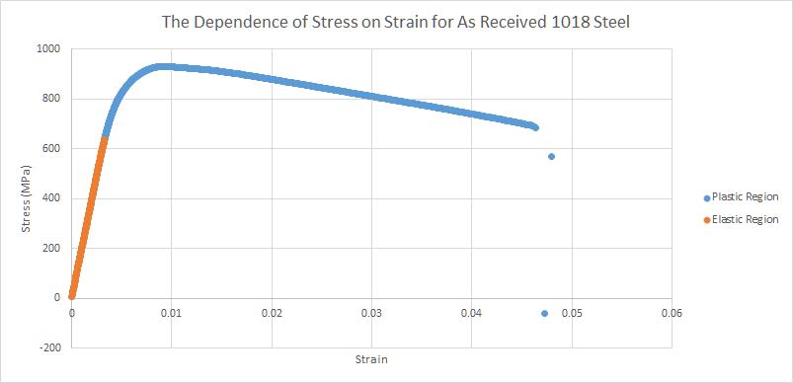

**Fig. 1.** [Description]

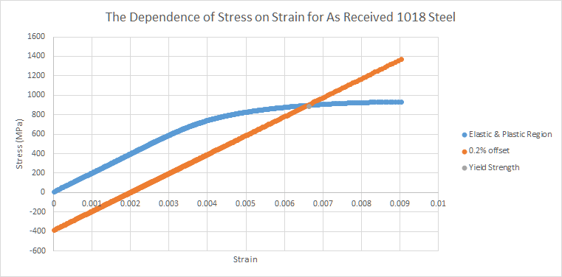

**Fig. 2.** [Description]

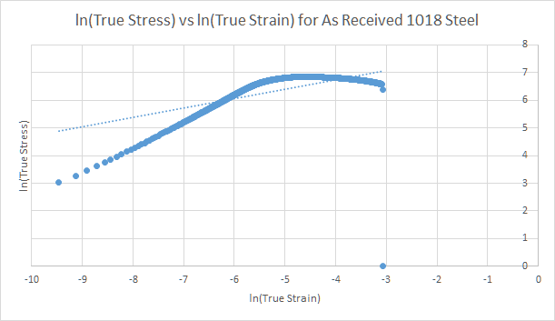

**Fig. 3.** [Description]

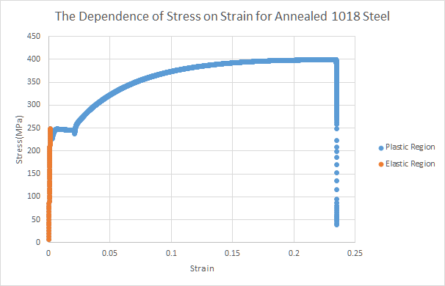

**Fig. 4.** [Description]

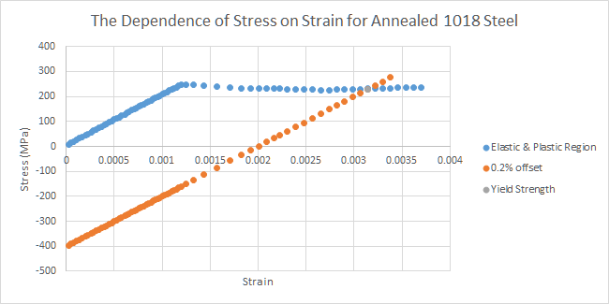

**Fig. 5.** [Description]

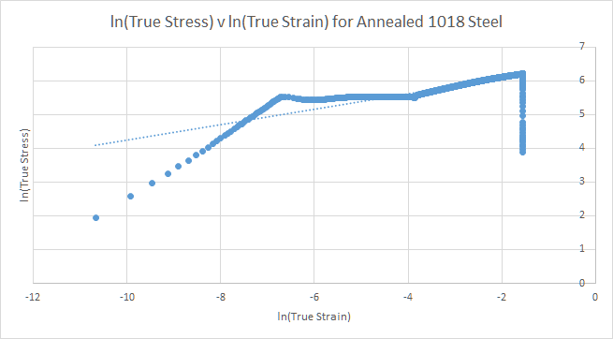

**Fig. 6.** [Description]